**KABOJJA JUNIOR SCHOOL**

**P.2 LITERACY I MID – TERM EXAMS I, 2024**

**Time Allowed: 2hrs 30 minutes**

**NAME**: ……………………………………………………………………………………………………………………….

**DISTRICT:** …………………………………………………… **CLASS:** ……………………………………….

1. Write three animals found at home.

i) _______________________ ii) ________________________

iii) _______________________

2. Name the animal that gives us milk.

_______________________________________________________

3. Who heads a family at home?

_______________________________________________________

4. Which animal guards our home?

_______________________________________________________

5. What do we get from a hen?

_______________________________________________________

6. Name any two types of transport.

i) ________________________ ii) __________________________

7. **Tick the ways of keeping personal hygiene**

by bathing by reading by combing hair

by jumping by brushing teeth

8. Name any two parts found on the head.

i) ________________________ ii) _________________________

9. **Match sense organs to their body senses.**

eyes tasting

tongue hearing

skin seeing

ear feeling

nose smelling

10. Name these parts of the leg. a

e b

d c

11. Name any two dangerous objects you know.

a) ________________________ b) _______________________

12. In which class are you?

_______________________________________________________

13. Mention any three important places near your school.

i) ________________________ ii) _________________________

iii) ________________________

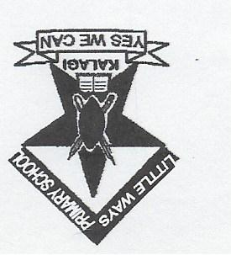14. Name these school symbols.

_______________ ________________

_______________ ________________

15. List four people we find at school

i) ______________________ ii) __________________________

ii) ______________________ iv) __________________________

16. Draw a school.

17. Who cooks food at school?

_______________________________________________________

18. What is the role of a school nurse at school?

_______________________________________________________

19. Write any three buildings found at school.

i) ______________________ ii) _________________________

iii) _____________________

20. Write the use of a bathroom.

_______________________________________________________

21. Write four things found in the classroom.

i) _________________________ ii) _______________________

iii) _________________________ iv) _______________________

22. Where do we find a teacher?

______________________________________________________

23. Name any one basic need you know.

_______________________________________________________